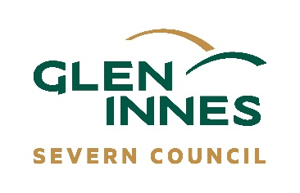
NOMINATION FOR MEMBERSHIP FORM
<Year>
<Name of Committee>

Name: ______________________________________________________________ Address: ____________________________________________________________________________

Phone: ______________________________________________________________ Email: _______________________________________________________________________________

Seconded by: _____________________________________________________________________

Please note: If under 18 years of age consent of parent or guardian is required.

Parent / Guardian consent: __________________________________________________________

Are you happy for this information to be used for purposes of being a member on this committee?

- Yes
- No

Requirements for appointment to the Community Committee is that:
You are aware of the conditions outlined in the Community Committees of Council Manual (the Manual). Some of the conditions outlined in section 13-14 are as follows:
- A Community Committee will comprise of those people endorsed by the General Manager or Council. Committee membership is on an annual basis. Members may stand for re-election at each Annual General Meeting (AGM).
- No qualifications are necessary for membership, though a commitment to the activities of the committee, a willingness to be actively involved in committee issues, and a willingness to attend training provided by Council, are essential.
- Community representatives nominated for a committee are to be residents of the LGA, carry out business within the LGA, or an employee in a business within the LGA.
- Members of Community Committees are volunteers, therefore, do not receive payment for services.
- You are prepared to operate under the Council’s Code of Conduct for Council Committee Members, Delegates and Advisors and Community Committees of Council Manual.
Privacy statement
Glen Innes Severn Council is committed to protecting your privacy. The personal information you provide in this form is for the purposes directly related to the functions of Council, specifically relating to this form. The information you provide will not be used or disclosed for other purposes unless you provide further consent or as authorised by law. This information is collected under the Privacy and Personal Information Protection Act 1998 (the Act) and if you require further information, please see our Privacy Management Plan at www.gisc.nsw.gov.au or contact Council on (02) 6730 2300.

